|  |  |
| --- | --- |
| **Lab Number:** | **1** |
| **Student Name:** | **Nimesh Ambre** |
| **Roll No :** | **17** |

## Title:

To Add Two Numbers, Print Number Entered by User, Swap Two Numbers, check Whether Number is Even or Odd

* 1. Implement using C++
  2. Implement using Java

## Learning Objective:

* + - Students will be able to write C++ and java program for simple arithmetic operations and take input from user.

## Learning Outcome:

* + - * Ability to execute a simple C++ and Java program with and without any inputs to the program.
      * Understanding the constructs in C++ and Java.

Course Outcome:

Understand object-oriented programming concepts and implement using C++ and Java

**ECL304.1**

## Theory:

**Difference between procedural and object oriented language Application of object orientation**

**Brief introduction to C++ and Java**

# JAVA PROGRAMS

## TO ADD TWO NUMBERS ALGORITHM:

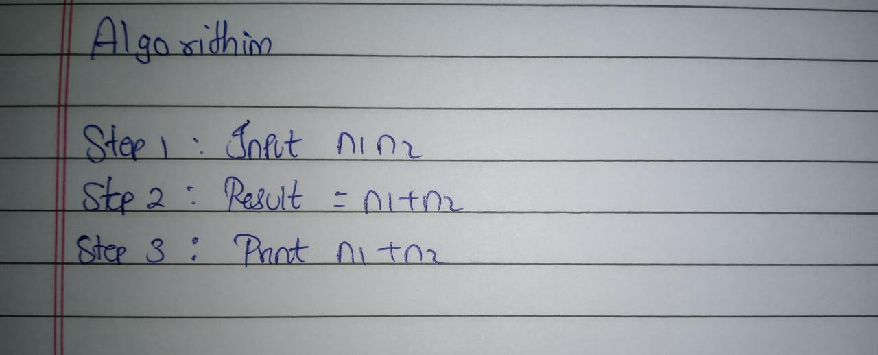

**PROGRAM:**

//To Add Two Numbers

public class Main

{

public static void main(String[] args)

{

int x = 5; int y = 6;

int sum = x + y ;

System.out.println("x + y =" +sum);

}

}

## OUTPUT:

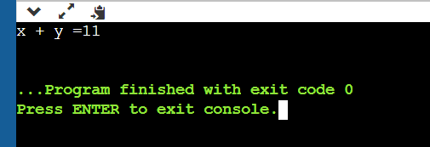

1. **TO PRINT NUMBERS ENTERED BY USER ALGORITHM:**

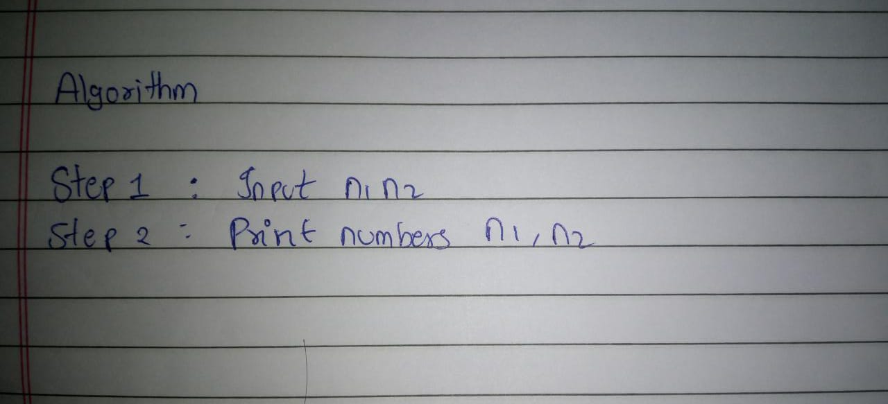

## PROGRAM:

## import java.util.*;

## public class MyClass {

## public static void main(String args[]) {

## int n1, n2,temp;

## Scanner sc = new Scanner(System.in);

## System.out.println("input number 1");

## n1=sc.nextInt();

## System.out.println("input number 2");

## n2=sc.nextInt();

## System.out.println(" n1 + n2=" +(n1+n2));

## }

## }

**OUTPUT:**

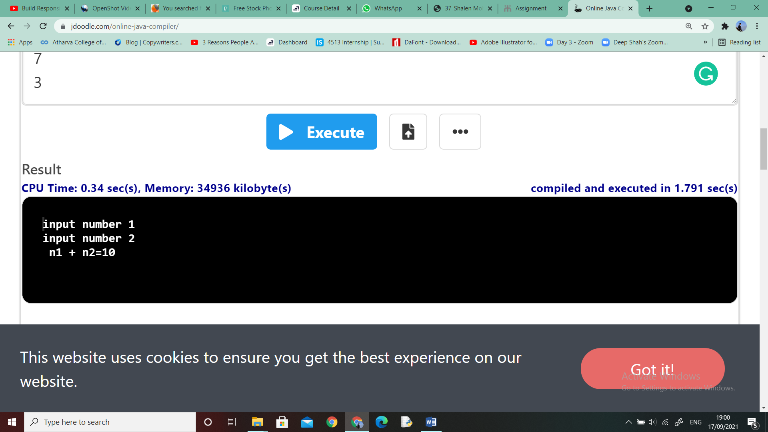

## TO SWAP TWO NUMBERS ALGORITHM:

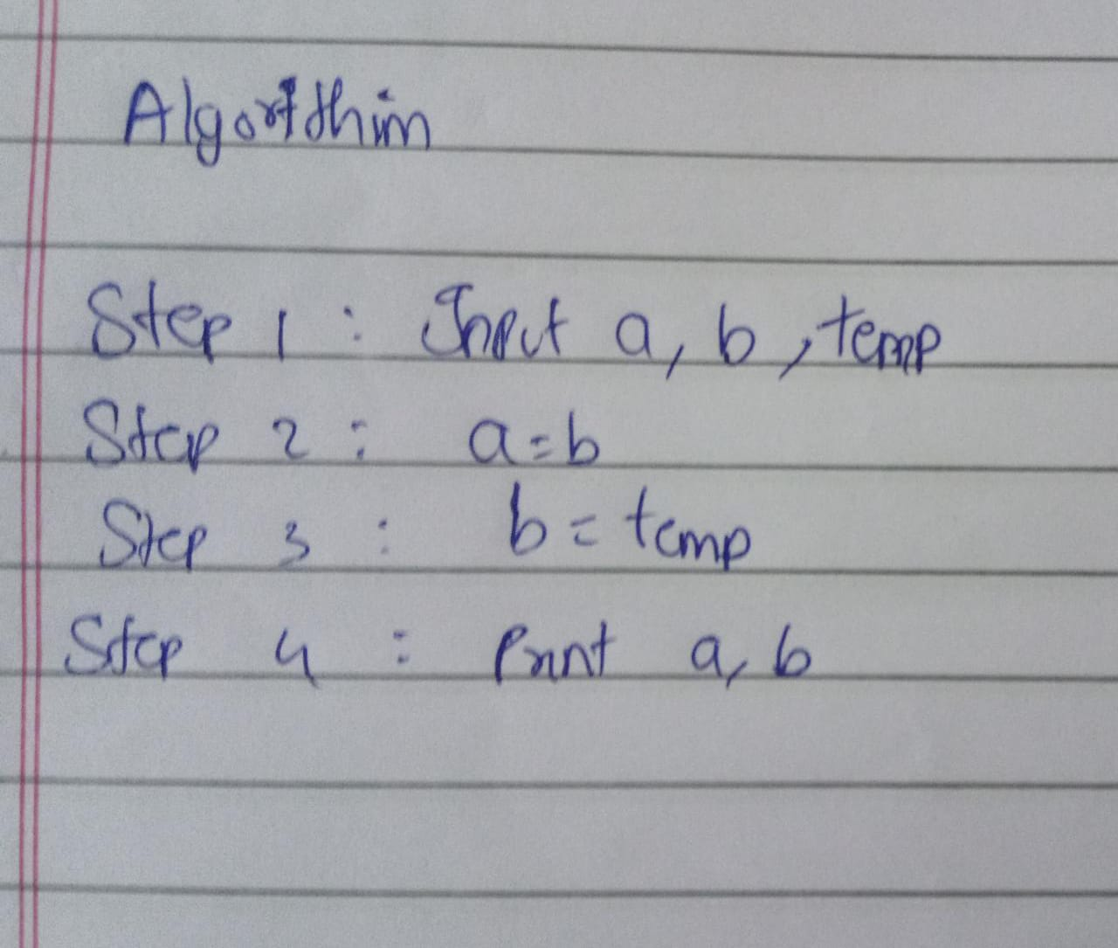

**PROGRAM:**

//to swap two numbers public class Main

{

public static void main(String[] args)

{

int n1 = 12, n2 = 24;

System.out.println("Before swapping"); System.out.println("First number = " + n1); System.out.println("Second number = " + n2);

n1 = n1 - n2; n2 = n1 + n2; n1 = n2 - n1;

System.out.println("After swapping");

System.out.println("First number = " + n1); System.out.println("Second number = " + n2);

}

}

## OUTPUT:

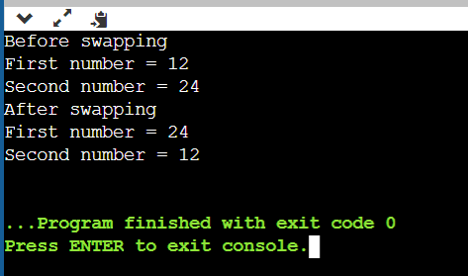

1. **TO CHECK WHETHER NUMBER IS EVEN OR ODD**

**ALGORITHM:**

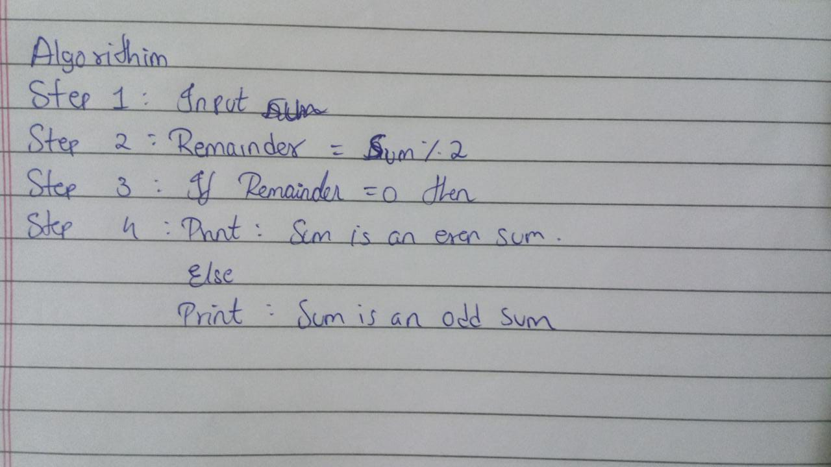

**PROGRAM:**

//to check whether no is even or odd. public class Main

{

public static void main(String[] args)

{

// Declare the integer variable int num = 10;

// If condition to check if the remainder is zero if (num % 2 == 0)

{

// If remainder is zero then this number is even System.out.println("Entered Number is Even");

}

else

{

// If remainder is not zero then this number is

// odd

System.out.println("Entered Number is Odd");

}

}

}

## OUTPUT:

